Practical
SUMMARY:-
The Travelling Salesman Problem (TSP) finds the minimum cost of visiting every city exactly once and returning to the starting city. This program uses recursion and backtracking to find the minimum travelling cost.

Complexity Type | Complexity
Best Case Time | (O(n^2 2^n))
Average Case Time | (O(n^2 2^n))
Worst Case Time | (O(n^2 2^n))
Space Complexity | The dynamic programming table stores results for different subsets of cities and current cities, requiring (O(n2^n)) memory.

Output:
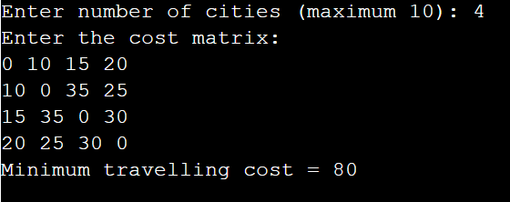

Conclusion:
Thus, the Travelling Salesman Problem was implemented successfully in C using recursion and backtracking to find the minimum travelling cost.

